1} https://kashtieducare.com/why-kashti
PREPARING LEARNERS FOR TOMORROW
- REPLACE 1ST IMAGE (KARAN+ASHOK JI) IN 3RD IMAGE
- 2ND IMAGE IS GOOD,
- CHANGE THE 1st IMAGE WITH THE IMAGE PASTED BELOW
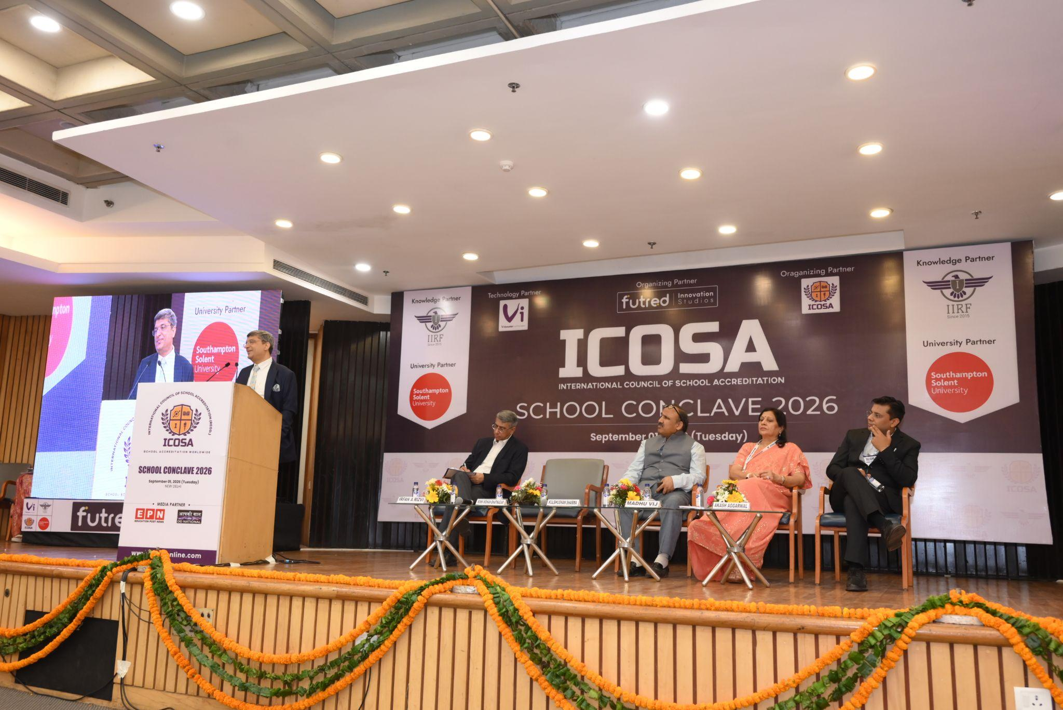
2} In the 2nd segment/section of WHY KASHTI
ADD TEHSE 2 IMAGES AS SCRIBBLED FROM THE G-DRIVE BELOW (OM PATHAK JI HERO; BVP 1; THE 3RD IMAGE IS PASTED BELOW(3RD IMAGE FROM HERE))
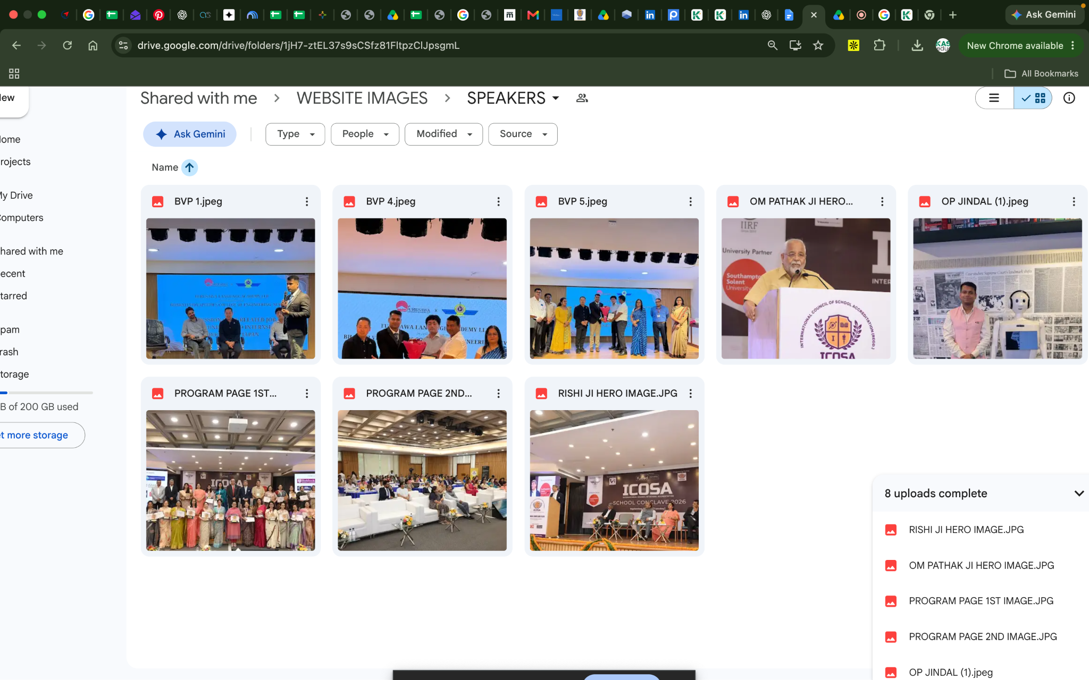
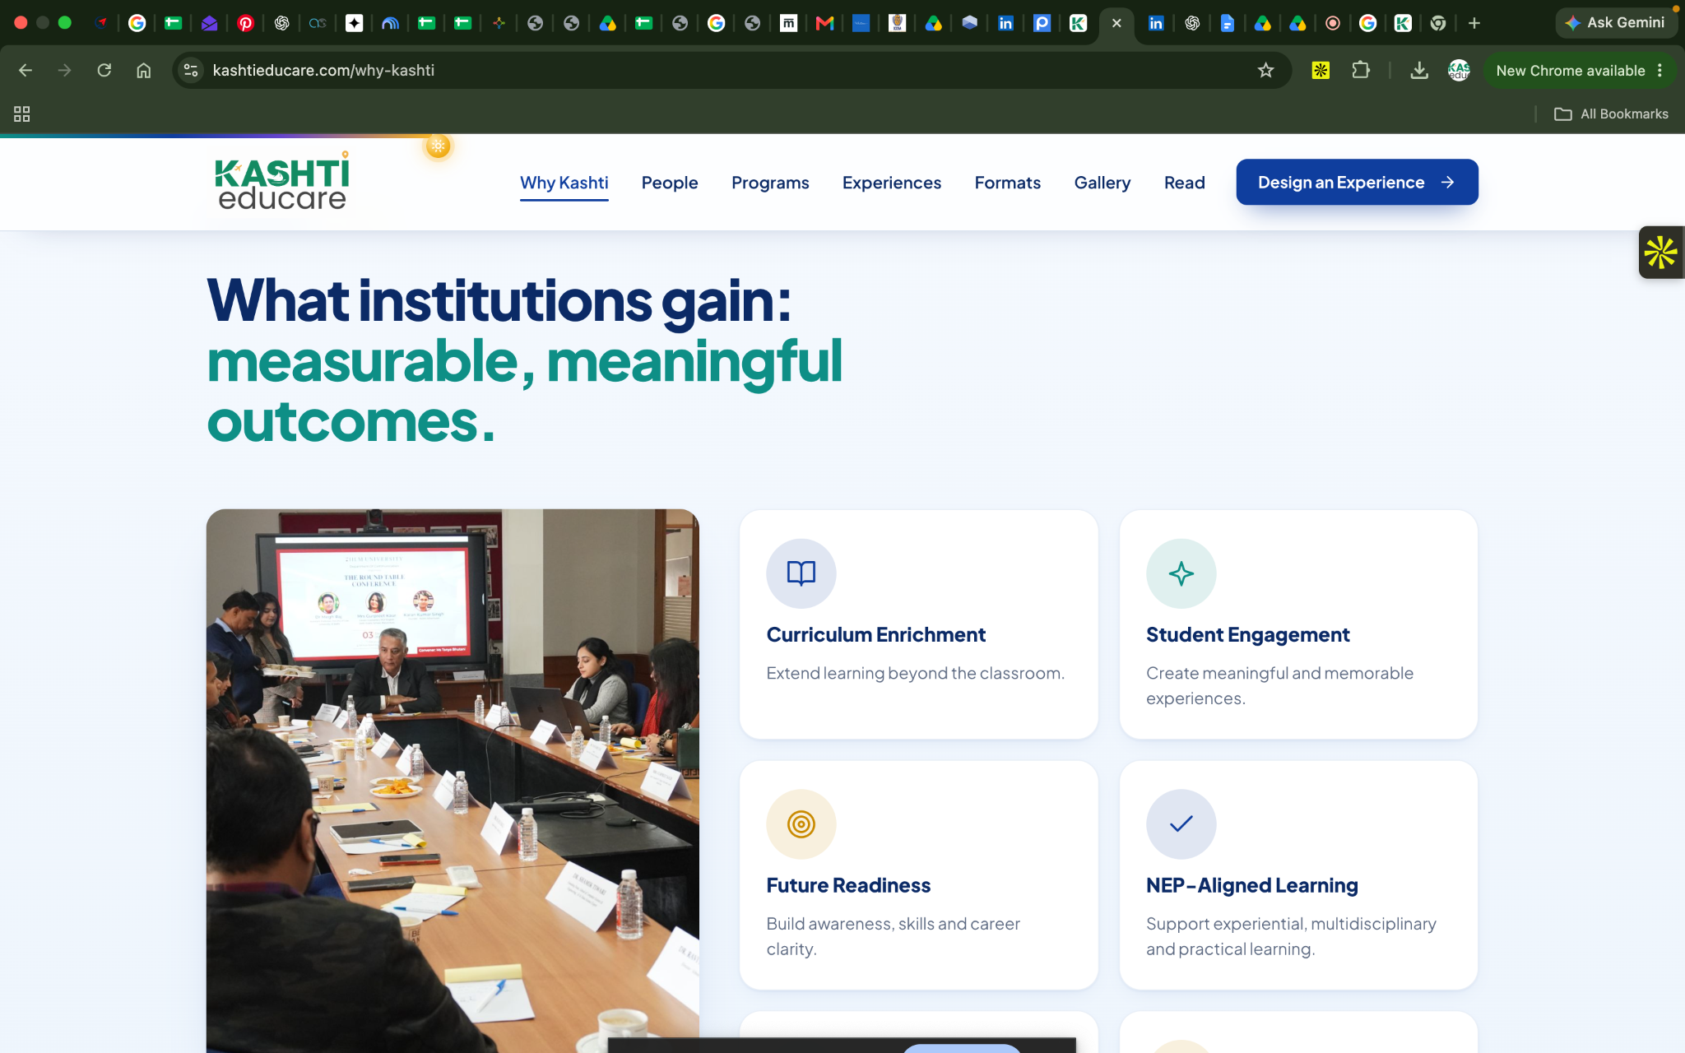
3RD IMAGE: BELOW(SEE)
MEXICAN IMAGE: https://drive.google.com/file/d/1Hn3ZCo15ul7o_hl3jOMsHjlnOK3hvMIO/view?usp=drive_link
3} 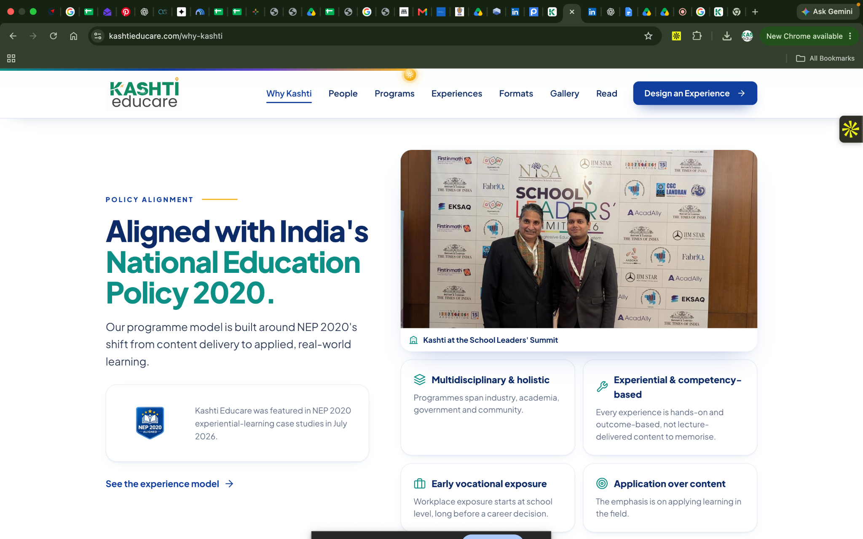
- THIS IMAGE WILL CHANGE TO THE BELOW IMAGE: (NO NEED TO FETCH IT FROM ANYWHERE)
- ALSO CAN WE MAKE SMALL TILES OF THE 4 THINGS MENTIONED BELOW THE IMAGE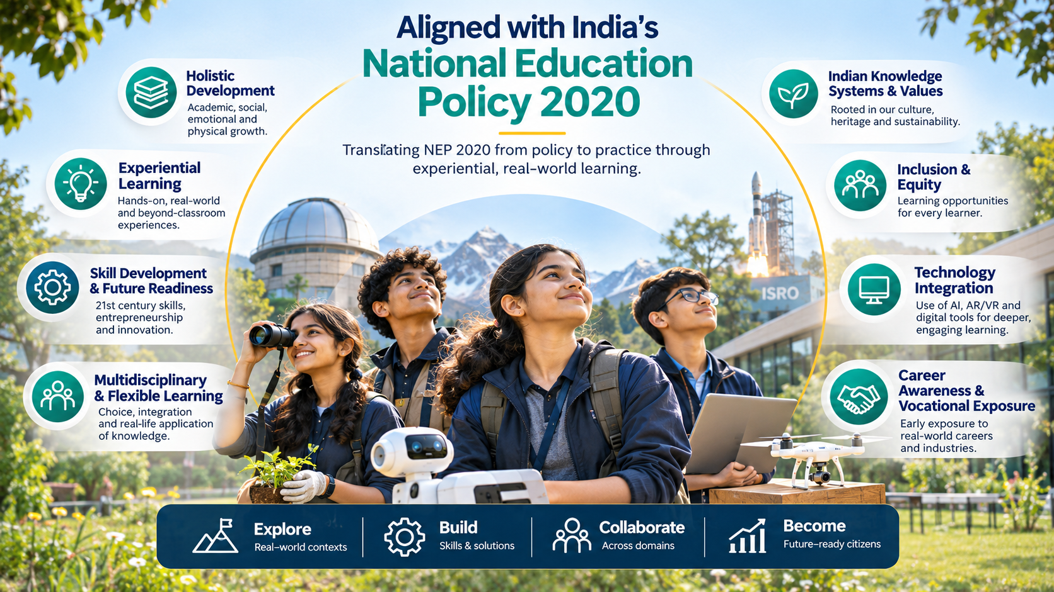
4} CAN WE REMOVE THE BIFURCATIONS HERE AND MAKE IT GENERIC… NO NEED TO SHOWCASE 3 SEGMENTS

